CS 255 System Design Document Template

This template lays out all the different sections that you need to complete for Project Two. Each section has guidance to prompt your thinking. You will need to continually reference the interview transcript as you work to make sure that you are addressing your client’s needs. There is no required length for the final document. Instead the goal is to complete each section based on what your client’s needs are. Remove this note when you are finished, and replace all bracketed text with the relevant information.

UML Diagrams

UML Use Case Diagram

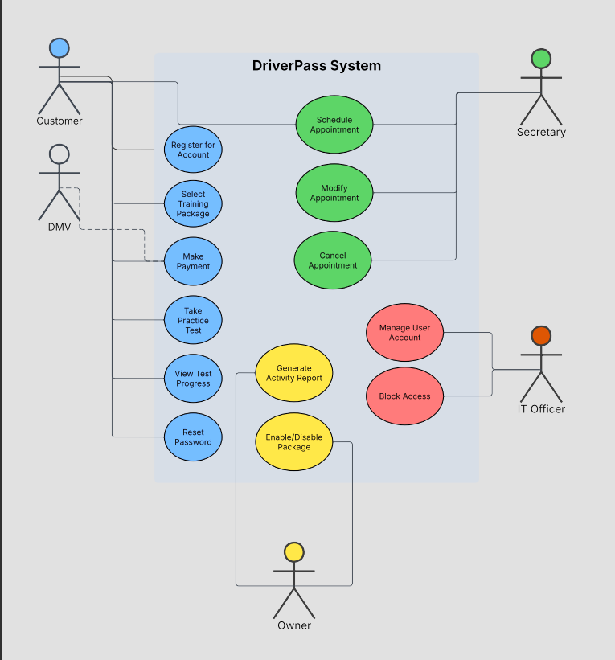

UML Activity Diagrams

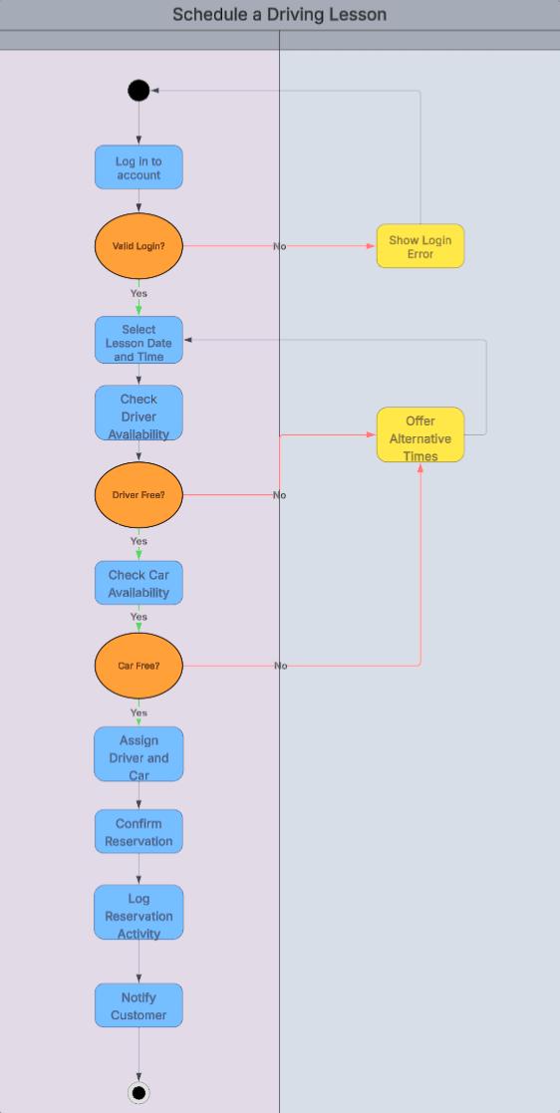
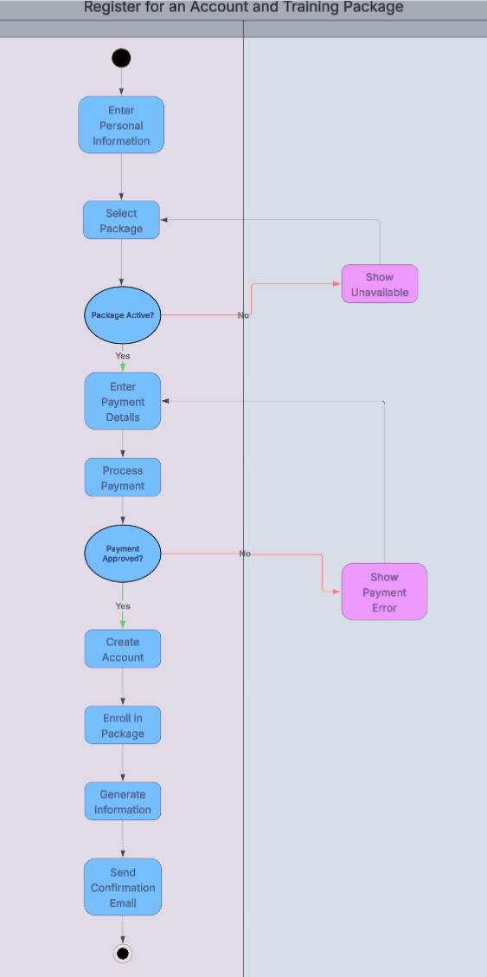

UML Sequence Diagram
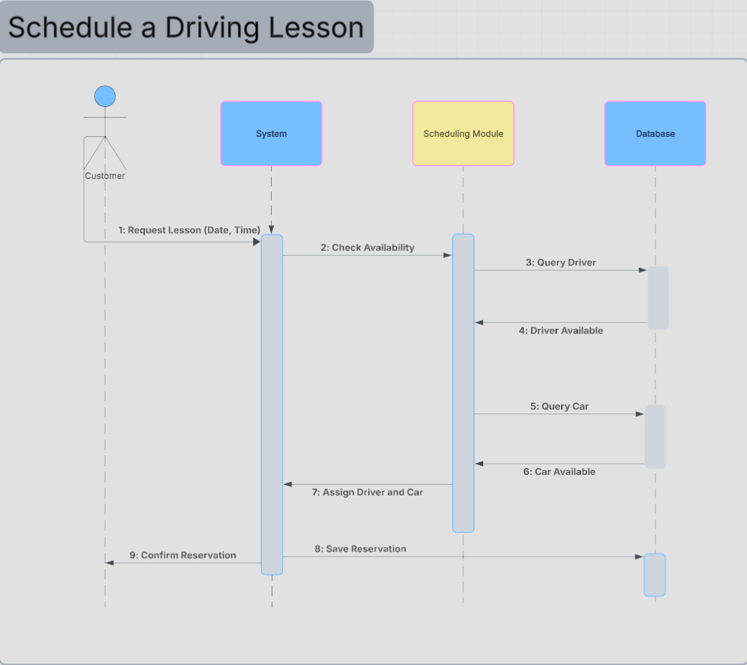

UML Class Diagram
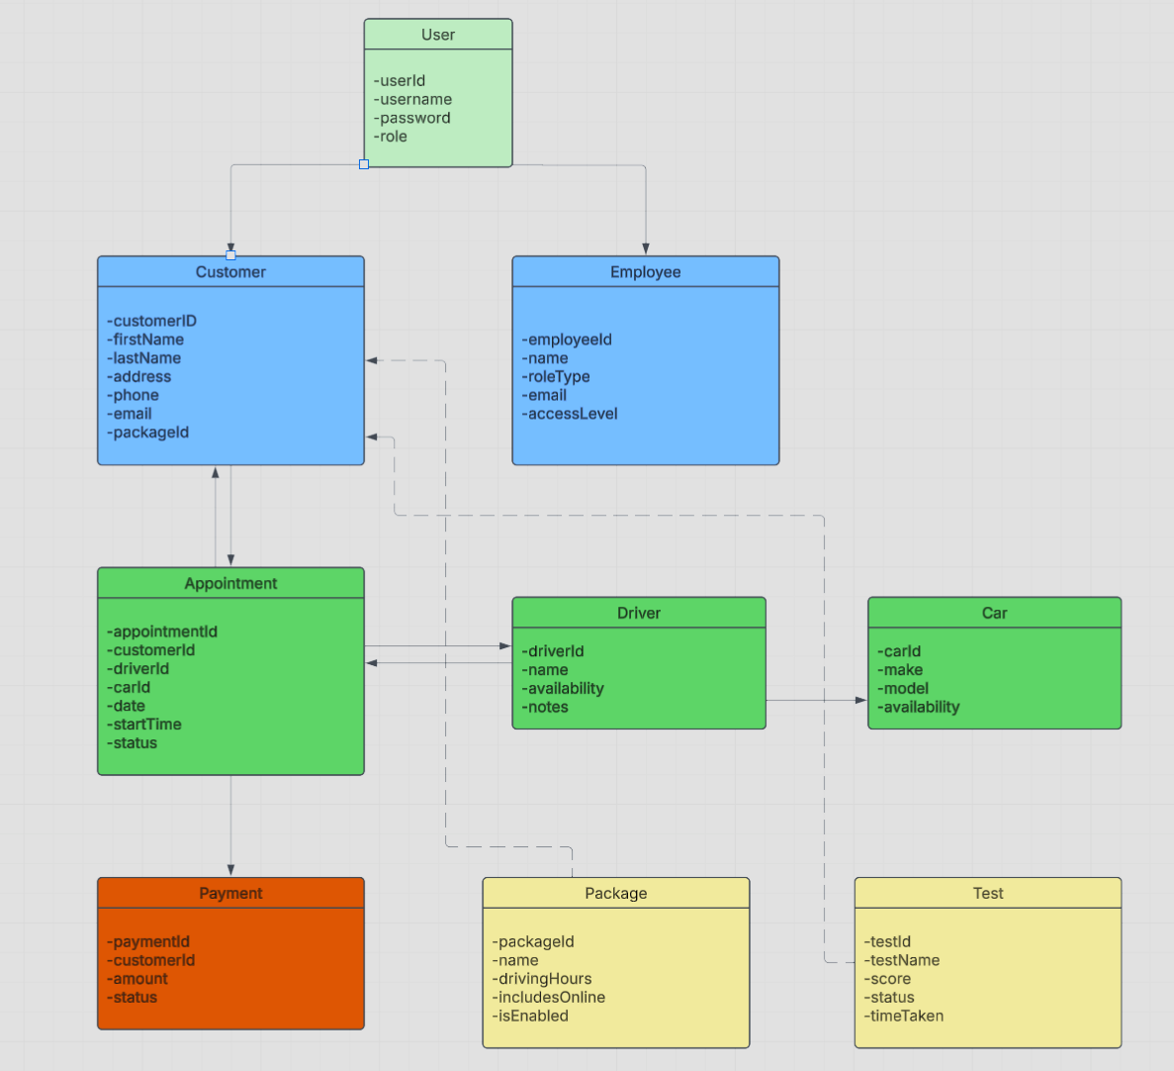

Technical Requirements

The technical requirements for the DriverPass system come straight out of the needs Liam and Ian described in the interview, combined with what the UML diagrams show the system must support. Here is what it will take to build and run it.

Starting with where the system lives, everything will be hosted in the cloud rather than on servers sitting in the DriverPass office. Ian was clear that he did not want to deal with backups, server maintenance, or security on his end, and cloud hosting takes all of that off his plate. A provider like AWS or Microsoft Azure handles the storage, the backups, and the ability to scale up when things get busy, so DriverPass never has to buy or maintain physical server hardware just to keep the system running.

The system itself will be a web application that runs in any normal browser, whether that is Chrome, Safari, Firefox, or Edge, on a computer, tablet, or phone. This is what makes it possible for Liam to check his data from anywhere and for customers to log in from whatever device they happen to have. There is no software to install, which makes things simple for everyone. Behind the scenes it will use a standard web setup, with one layer handling what the user sees and another handling the actual work like scheduling lessons, managing accounts, and pulling reports.

For storing data, the system needs a relational database, something like MySQL or PostgreSQL. This is where all the customer records, appointments, driver and car assignments, packages, test results, payments, and activity logs get kept. The class diagram lines up with this directly, since the way a customer connects to multiple appointments and each appointment ties to one driver and one car is exactly the kind of structure a relational database is built for. One important detail is that the system only lets data be changed while the user is online, which avoids the duplicate-record problem Sam pointed out during the interview.

Security is a big piece of this. Every user logs in with their own username and password, and what they can do is locked to their role, so a customer can never wander into the tools meant for staff. All the data moving between the user and the system gets encrypted with SSL/TLS so it cannot be intercepted. Customers can reset their own passwords if they forget them, and the IT officer can reset or shut down any account when needed. If someone keeps failing the login on purpose, the system locks that account and flags the IT officer so they can take a look.

The system also must talk to a few outside services. The most important one is a connection to the DMV so that whenever the rules or practice questions change, the system gets updated automatically and the practice tests stay accurate. A third-party payment processor will handle the credit card side of registration securely, and the system needs to be able to export reports to Excel, which Liam specifically asked for.

As for hardware, there is not much DriverPass needs to buy. Because everything runs in the cloud and through a browser, the only equipment on their side is regular internet-connected devices like the office computers, laptops, or tablets the staff already use. Customers just use their own phones or computers. That keeps the upfront cost low and the setup simple.

